**Arduino DS18B20 temperature sensor**

**Code:**

#include <OneWire.h>

#include <DallasTemperature.h>

#define ONE_WIRE_BUS 4

OneWire oneWire(ONE_WIRE_BUS);

DallasTemperature sensors(&oneWire);

float Celsius = 0;

float Fahrenheit = 0;

void setup() {

sensors.begin();

Serial.begin(9600);

}

void loop() {

sensors.requestTemperatures();

Celsius = sensors.getTempCByIndex(0);

Fahrenheit = sensors.toFahrenheit(Celsius);

Serial.print(Celsius);

Serial.print(" C ");

Serial.print(Fahrenheit);

Serial.println(" F");

delay(1000);

}

**Circuit:**

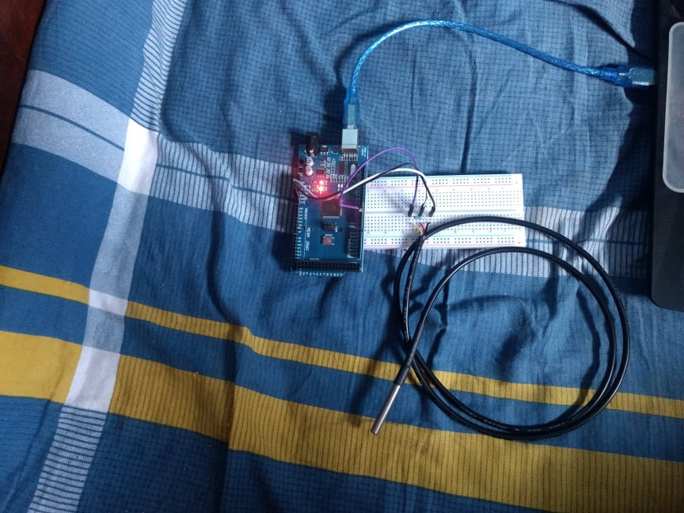

**Result:**

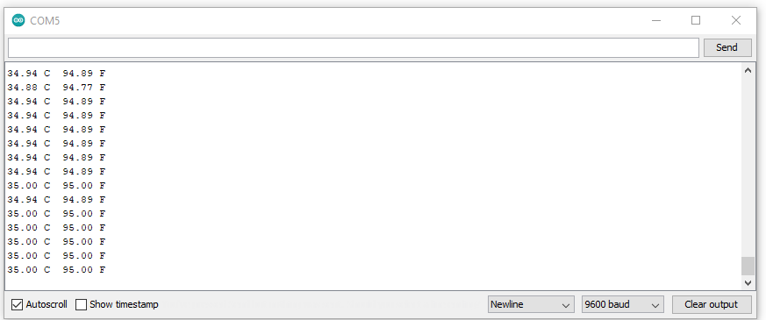

**NEO-6M GPS Module**

**CODE:**

void setup() {

// put your setup code here, to run once:

}

void loop() {

// put your main code here, to run repeatedly:

}

**Circuit:**

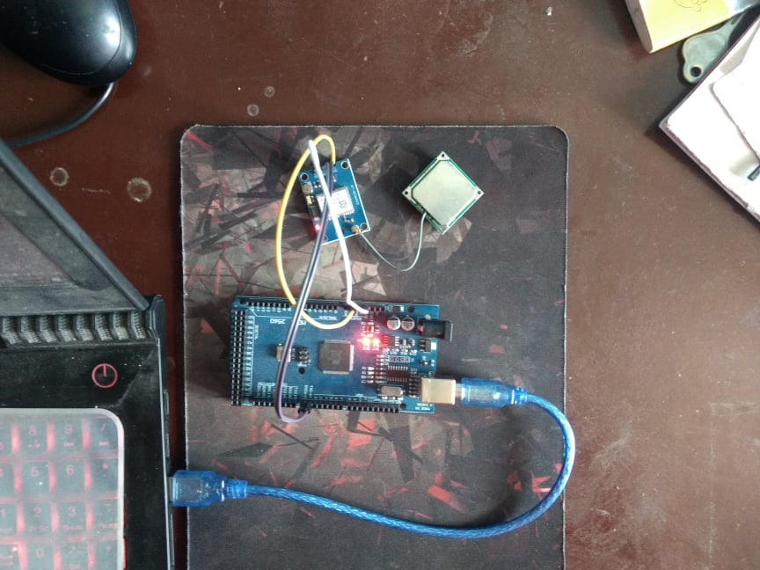

**Output:**

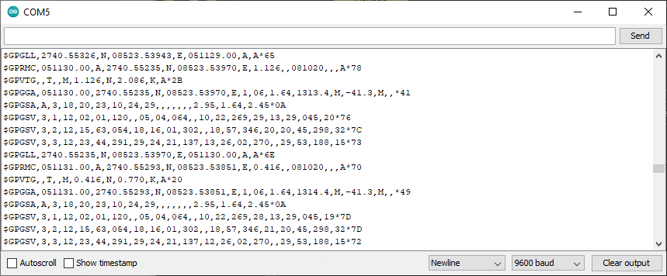

$GPGLL,2740.55326,N,08523.53943,E,051129.00,A,A*65

$GPRMC,051130.00,A,2740.55235,N,08523.53970,E,1.126,,081020,,,A*78

$GPVTG,,T,,M,1.126,N,2.086,K,A*2B

$GPGGA,051130.00,2740.55235,N,08523.53970,E,1,06,1.64,1313.4,M,-41.3,M,,*41

$GPGSA,A,3,18,20,23,10,24,29,,,,,,,2.95,1.64,2.45*0A

$GPGSV,3,1,12,02,01,120,,05,04,064,,10,22,269,29,13,29,045,20*76

$GPGSV,3,2,12,15,63,054,18,16,01,302,,18,57,346,20,20,45,298,32*7C

$GPGSV,3,3,12,23,44,291,29,24,21,137,13,26,02,270,,29,53,188,15*73

$GPGLL,2740.55235,N,08523.53970,E,051130.00,A,A*6E

$GPRMC,051131.00,A,2740.55293,N,08523.53851,E,0.416,,081020,,,A*70

$GPVTG,,T,,M,0.416,N,0.770,K,A*20

$GPGGA,051131.00,2740.55293,N,08523.53851,E,1,06,1.64,1314.4,M,-41.3,M,,*49

$GPGSA,A,3,18,20,23,10,24,29,,,,,,,2.95,1.64,2.45*0A

$GPGSV,3,1,12,02,01,120,,05,04,064,,10,22,269,28,13,29,045,19*7D

$GPGSV,3,2,12,15,63,054,18,16,01,302,,18,57,346,21,20,45,298,32*7D

$GPGSV,3,3,12,23,44,291,29,24,21,137,12,26,02,270,,29,53,188,15*72

$GPGLL,2740.55293,N,08523.53851,E,051131.00,A,A*61

$GPRMC,051132.00,A,2740.55277,N,08523.53822,E,0.573,,081020,,,A*7F

$GPVTG,,T,,M,0.573,N,1.062,K,A*27

$GPGGA,051132.00,2740.55277,N,08523.53822,E,1,06,1.64,1315.3,M,-41.3,M,,*42

$GPGSA,A,3,18,20,23,10,24,29,,,,,,,2.95,1.64,2.45*0A

$GPGSV,3,1,12,02,01,120,,05,04,064,,10,22,269,28,13,29,045,19*7D

$GPGSV,3,2,12,15,63,054,19,16,01,302,,18,57,346,21,20,45,298,32*7C

$GPGSV,3,3,12,23,44,291,29,24,21,137,12,26,02,270,,29,53,188,12*75

$GPGLL,2740.55277,N,08523.53822,E,051132.00,A,A*6C

$GPRMC,051133.00,A,2740.55299,N,08523.53806,E,0.562,,081020,,,A*78

$GPVTG,,T,,M,0.562,N,1.040,K,A*27

$GPGGA,051133.00,2740.55299,N,08523.53806,E,1,05,3.70,1315.6,M,-41.3,M,,*44

$GPGSA,A,3,18,20,23,10,29,,,,,,,,7.61,3.70,6.65*03

$GPGSV,3,1,12,02,01,120,,05,04,064,,10,22,269,28,13,29,045,18*7C

$GPGSV,3,2,12,15,63,054,18,16,01,302,,18,57,346,22,20,45,298,32*7E

$GPGSV,3,3,12,23,44,291,29,24,21,137,09,26,02,270,,29,53,188,12*7F

$GPGLL,2740.55299,N,08523.53806,E,051133.00,A,A*6B

$GPRMC,051134.00,A,2740.55276,N,08523.53830,E,0.519,,081020,,,A*77

$GPVTG,,T,,M,0.519,N,0.962,K,A*23

$GPGGA,051134.00,2740.55276,N,08523.53830,E,1,05,3.70,1315.9,M,-41.3,M,,*48

**After parsing:**

